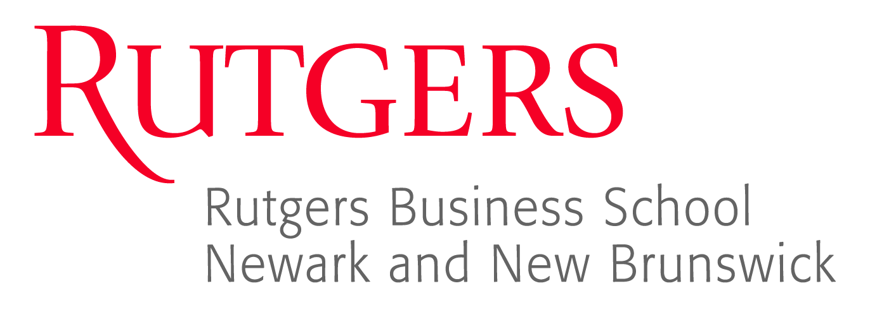
11th Fraud Conference
Thursday, June 25, 2015
raw.rutgers.edu/11fraud

The New Jersey Chapter of Association of Certified Fraud Examiners (ACFE) is co-sponsoring a Fraud Conference with the Rutgers Business School. This event offers a unique forum to discuss emerging issues in the area of Fraud with experts and an outstanding opportunity to earn reasonable CPE credits in today’s economic times. The event will be held on June 25, 2015 at the Rutgers Business School located at One Washington Park, Room 512, Newark, New Jersey, 07102, from 8:00 am to 4:30 pm. Parking is available at numerous lots at the individual’s expense.

Conference attendees will receive an estimated eight (8) CPE credits in Auditing.
NASBA Sponsor Identification #116231

The cost for the event is as follows:
$150 for ACFE /ISACA/AGA members with a minimum of 48 hours advanced reservation.
$175 for ACFE/ISACA/AGA members with no prior reservation.
$175 for non-ACFE/ISACA/AGA members with a minimum of 48 hours advanced reservation.
$200 for non-ACFE/ISACA/AGA members with no prior reservation.

All checks will be collected at the door and should be made payable to “Rutgers-The State University”. No credit cards will be accepted. To make a reservation, email the attached registration form to Professor Karl Dahlberg, Rutgers Business School, Department of Accounting & Information Systems at Dahlberg@andromeda.rutgers.edu.

Intended Audience: CPAs, Fraud Examiners, and professionals with an interest in ethics, fraud and computer systems.

Program Description: Professionally-qualified speakers will present various fraud topics of current interest.

Learning Objectives: To provide updated information in the following areas:
- Preventing, Detecting, Investigating and Remediating Corporate Fraud
- The Investigative Audit
- Assessing for Audit Risk
- Case Studies on Ponzi Schemes

Delivery Method: Group live
Program Level: Update
Prerequisites: None
Advance Preparation: None
Refund Policy: 100% refund if cancelled at least 48 hours prior to the event
Complaint Resolution: Complaints will be resolved by the Rutgers Accounting Research Center

Rutgers Business School is registered with the National Association of State Boards of Accountancy (NASBA) as a sponsor of continuing professional education on the National Registry of CPE Sponsors. State boards of accountancy have final authority on the acceptance of individual courses for CPE credit. Complaints regarding registered sponsors may be submitted to the National Registry of CPE Sponsors through this website: www.learningmarket.org.

Scheduled Speakers and Topics

Roles and Responsibilities: Preventing, Detecting, Investigating and Remediating Corporate Fraud
Ellen Zimiles, Esq., Global Head of Investigations and Compliance, Navigant Consulting
Nancy Haig, MBA, CIA, CFE, CRISC, CBA, CFSA, CCSA, CRMA, Director of Internal Audit (CAE) & Compliance for a global consulting firm

According to the ACFE Report to the Nations on Occupational Fraud and Abuse – 2014 Global Fraud Study, companies lose, on average, 5% of revenue each year to fraud. So, who in the organization is responsible for preventing fraud? For detecting fraud, if and when it occurs? For the investigation of fraud? And for remediating controls that were found to be ineffective? Ellen Zimiles and Nancy Haig will describe, and illustrate through case studies, the responsibilities and roles of internal audit, compliance, legal and security functions; and external auditors, legal counsel and investigators, when it comes to dealing with fraud.

Ellen Zimiles has more than 30 years of litigation and investigation experience, including 10 years as a federal prosecutor, and is currently head of Navigant’s Global Investigation and Compliance Practice. Before coming to Navigant, Ellen co-founded Daylight Forensic & Advisory, an international consulting firm, which she ran prior to Daylight being acquired by Navigant. Ellen was a principal at a "Big Four" accounting firm, where she coordinated the forensic practice across all industry segments and was practice leader for the financial services industry. She is a leading authority on anti-money laundering programs, corporate governance, regulatory and corporate compliance, fraud control and public corruption matters. Ellen has worked with a multitude of financial institutions preparing for regulatory exams. She also has extensive experience in developing remediation programs, serving as a regulatory liaison and independent monitor, and advising organizations that are the subject of a monitorship. Before her Big Four experience, Ellen was an assistant United States attorney in the Southern District of New York for more than 10 years. She served in the civil and criminal divisions and was chief of the forfeiture unit for more than six years. Ellen was responsible for many high-profile money laundering, fraud and forfeiture cases. In recognition for her contributions as a federal prosecutor, Ellen received the United States Department of Justice’s John Marshall Award for Outstanding Service and the United States Department of Health and Human Services’ Integrity Award. Ellen earned a bachelor's degree at Brooklyn College and a law degree at Syracuse University College of Law, where she served as an editor of the law review.

Nancy Haig has over 30 years of internal audit and compliance experience in the financial services, healthcare, professional services and pharmaceutical industries. Nancy is currently the head of internal audit and compliance for a global consulting firm, and was previously the VP of internal audit for a global Japanese pharmaceutical manufacturer. Nancy serves on the North American board of the Institute of Internal Auditors (IIA) as a member of the publications advisory committee and the editorial board. Nancy earned MBA and BS degrees from Wagner College, Staten Island, NY, and a second MBA from Capella University.

The Investigative Audit (Prevention and Detection)
David Gannaway, MBA, CFE, CAMS, EA, Principal - Litigation Support, O’Connor Davies, LLP

With bribery and corruption gaining momentum to obtain/maintain business, conducting investigative audits can assist a company in identify potential fraudulent activities. Whistleblowers with inside information are coming forward to prosecutors and detailing illegal schemes. Their rewards can be substantial depending upon the information provided and the extent of the fraud schemes. Performing investigative audits may assist companies in rooting out bad employees and save the company from embarrassing headlines.

David will discuss the following topics, including “Red Flags” associated with:
- Fraud Risk Assessment
  - Evaluate Fraud Risk Factors
  - Identify Possible Fraud Schemes
  - Prioritize Identified Fraud Risks
  - Evaluate Whether Mitigation Controls Exist or are Effective
  - Clearly Communicate Zero Tolerance Policy
  - Monitor the Program and Periodically Re-assess Risk Factors
- Fraud Deterrence

David Gannaway joined O’Connor Davies in February 2015 as a Principal in the Litigation Support Group. David has over 25 years of combined experience as a former IRS Criminal Investigation Special Agent and consultant in managing and unraveling domestic and international complex white-collar financial fraud schemes across multiple business sectors including healthcare, financial services, and non-profit. David earned a BS degree from Bristol College and an MBA degree from Fordham University’s Graduate School of Business Administration.

Considerations for Assessing Fraud Risk
Michael Dixon, MBA, CPA, CIA, CFE, CISA, Engagement Manager, Experis

Surveys over time generally indicate that 5 to 7% of an organization’s revenue is lost each year to fraud. Using the ACFE’s Fraud Prevention Check-up as guide, Michael will outline an affordable and simple way to identify gaps in your organization’s fraud prevention processes. By identifying risks early, you have a chance to fix the problem before losing money and becoming a victim of fraud.

As one size does not fit all, Michael will also discuss elements of conducting a fraud risk assessment for your consideration with focus on COSO 2013. Additionally, Michael will be joined by several panelists who will share how their organizations assessed the risk of fraud, including some of the factors or influences embraced by their organization while performing these assessments.

Michael Dixon has been interested in fraud since his first professional job working for the Commonwealth of Pennsylvania. He observed many peculiarities while auditing transportation related grants, agreements and change orders where Federal and State funds were involved. In 1999, Michael obtained his Certified Fraud Examiners designation. He has performed many fraud related type of engagements focusing on fraud prevention and enhancing controls. During his tenure with BlueCross of Northeastern PA, Michael assisted with the Special Investigations Unit and referred several matters to law enforcement. He has also held positions in time at YORK® International Corporation, C-COR Incorporated, the Commonwealth of Pennsylvania and several CPA firms. Michael has been with Experis for over ten years where he assists a diverse client with a focus on manufacturing and construction related engagements. He is also one of the firm’s subject matter experts on the IIA’s Quality Assessment and Improvement Program (QAIP) and External Quality Assessments (EQAs). Michael earned a BA in Accounting and MBA degrees from Bloomsburg University of Pennsylvania.

Ponzi Schemes
Gregory Yankow, Special Agent, Federal Bureau of Investigation

Compliance and ethics programs are designed to detect, mitigate and prevent fraud; however, it is not uncommon for organizations to spend money and resources on compliance without fully understanding the purpose it is actually serving. One problem is that many blur the compliance risk management efforts with other forms of enterprise risk management, leaving organizations, already short on resources, uncertain about how best to scope and structure effective risk assessments.

In any kind of risk assessment, an organization will isolate risks that affect the organization, understand best practices, benchmark with peers, appraise and budget the cost of remediation, prioritize mitigation strategies, and use generally-accepted project management techniques to remediate the risks. This workshop will help rationalize otherwise complex compliance initiatives and streamline ways to achieve measurable and effective results.

The goal of Gregory’s workshop is to collaborate and devise ways to simplify the process for assessing risk and improving methods for tracking progress and reporting to the board and upper management.

In this interactive session we will:
- Review the drivers for why organizations are constrained to manage risk continuously
- Explore the importance of understanding organizational culture as a means for mitigating risk
- Develop common process language for measuring progress
- Integrate objective checkpoints and measurable key risk indicators
- Design organic dashboards and timelines to highlight and report progress
- Build the case for assessment and remediation as part of the strategic planning process
- Partner with audit, IT and other key corporate functions for testing, training, policymaking and ongoing awareness.

Gregory Yankow has been a Special Agent with the FBI for 13 years and has worked financial crimes since 2003. He was the recipient of the 2012 FLEO Investigator of the Year Award and has been nominated for the FBI Directors Award twice during his career. Gregory’s investigation into the Nevin Shapiro Ponzi Scheme was featured on the television program American Greed (Major League Fraud) and ESPN’s 30 for 30 (The U Part II). Gregory is a certified FBI Firearms Instructor and an FBI Fitness Advisor. Prior to joining the FBI, Gregory worked for six years in the investment industry. He holds a BS in Computer Science, is a licensed pilot, and enjoys hiking and mountaineering.

