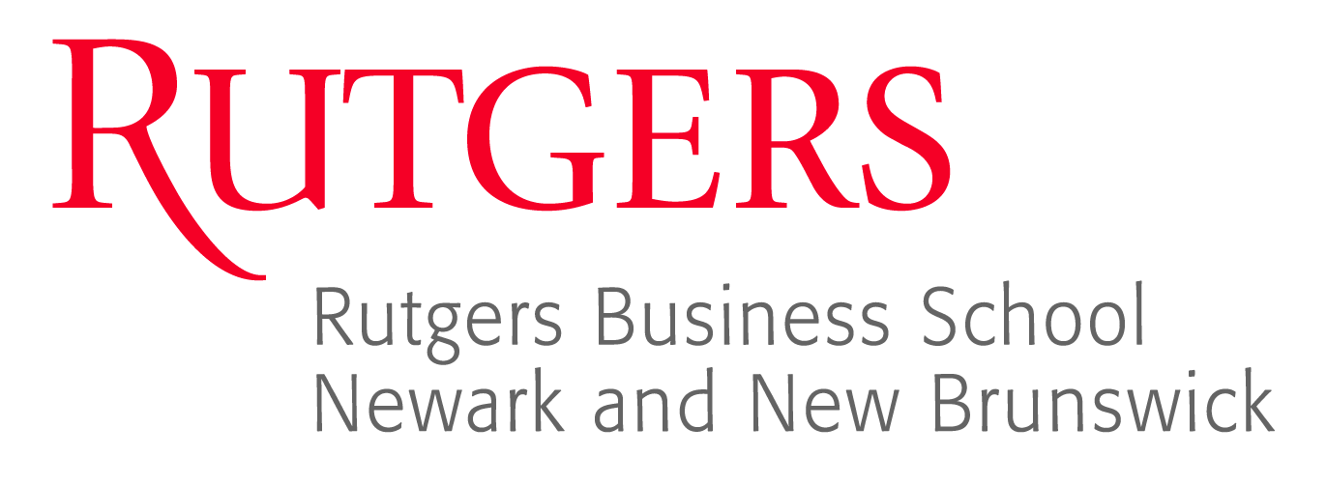
11th Fraud Seminar
Thursday, June 25, 2015
1 Washington Park, Room 512
Newark, NJ 07102
raw.rutgers.edu/11fraud

Agenda

8:00 – 8:30 Registration and coffee – Room 512

8:30 – 10:10 Roles and Responsibilities for Preventing, Detecting, Investigating, and Remediating Corporate Fraud
Ellen Zimiles, Esq. Global Head of Investigations and Compliance, Navigant Consulting, and
Nancy Haig, MBA, CIA, CFE, CRISC, CBA, CFSA, CCSA, CRMA, Director of Internal Audit (CAE) & Compliance for a global consulting firm

10:10 – 10:20 BREAK

10:20 – 12:00 The Investigative Audit
David Gannaway, MBA, CFE, CAMS, EA, Principal – Litigation Support, O’Connor Davies, LLP

12:00 – 12:30 LUNCH

12:30 – 2:10 Considerations for Assessing Fraud Risk
Michael Dixon, MBA, CPA, CIA, CFE, CISA, Engagement Manager, Experis

2:10 – 2:30 BREAK

2:30 – 4:10 Ponzi Schemes
Gregory Yankow, Special Agent, Federal Bureau of Investigation

