APPLICATION
AUDIT ANALYTICS CERTIFICATE PROGRAM
(Non-Matriculated Status)

personal information

NAME _______________________________________________________________
Ms./Mr. Last First Middle

ADDRESS _______________________________________________________________
Street Apt. #

_______________________________________________________________
Town State Zip

HOME PHONE: (____) _____________________ CELL: (____) _____________________

E-MAIL: ____________________________________________________________________________

EDUCATION
List in chronological order all colleges, universities attended since secondary school.

I. Name of Institution: ______________________________________________________
Location: _______________________________________________________________
Dates of Attendance: ________________________ Degree: ________ ___________

II. Name of Institution: ______________________________________________________
Location: _______________________________________________________________
Dates of Attendance: _________________________Degree:______________________

EMPLOYMENT
Employer: __________________________________________________________________
Position: ___________________________________________________________________
Business Address: ____________________________________________________________
Business Phone: ( ) _______________________Fax: ( ) __________________________
Email: ____________________________________

____________________________________ ____________________________________
Signature Date

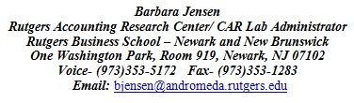
Please send INITIAL APPLICATION & RESUME to:

